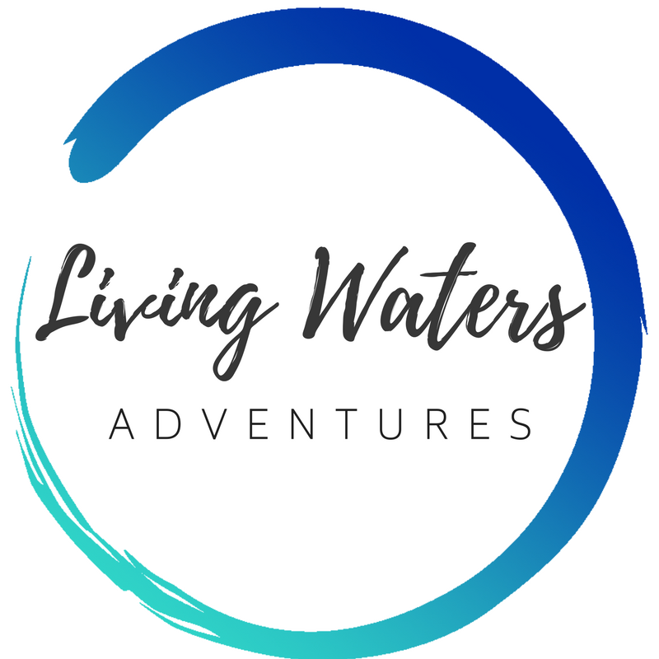

Rancho Santa Marta
Mission Trip
Final Application Form
CHILD’s Version
(UNDER 18 years of age by end of outreach)

Name:_________________________________________

Instructions:
- Except where indicated, complete this entire form if you will be younger than 18 years of age by the end of the outreach.
- Follow the check list below and mail this application form to:
Living Waters Spanish, PO Box 744, Canby, OR 97013.
Apply:
- Pray about whether God would have you go on this outreach.
- Complete the Preliminary Application Form, online.
- Pay the trip deposit online (or mail a check to Living Waters Spanish, PO Box 744, Canby, OR 97013).

Complete the Final Application Form, including the following:
- Medical Emergency Contact Information
- Notarized: Authorization and Consent for Medical Treatment form.
  - Plus copy of both sides of your medical insurance card
- Reference Questionnaire – to be filled out by a Pastor or Christian Leader (not required if you’ve been on a previous Living Waters Spanish mission trip, or if the Rieggs vouch for you.)
--------------------------------------
If you are applying for an international trip outside of the US, also complete the following:
- If you do not have a passport that is valid for 6 months past your trip return date, order one at least 6 weeks before the departure date. Order at: US Passport, or if near Lake Oswego, Oregon, their Passport Office is helpful and efficient.
- Activity Release of Liability form.
- Get any required inoculations from your doctor long before departure. If you are not fully vaccinated, also sign the Participant Release of Liability form for Vaccinations.
- Notarized: Minor Travel Consent Form.
--------------------------------------
- Mail this completed application form to Living Waters Spanish, PO Box 744, Canby, OR 97013.
- Submit the balance of the outreach payment on time online, or mail it to Living Waters Spanish, PO Box 744, Canby, OR 97013.
Preparing to go:
- Book your flight to the meeting point and be sure you are arriving early enough and departing late enough to meet the parameters of your trip schedule. It is wise to buy flight insurance.
- Send personal letters to friends and family asking for prayer and financial support. Possible prayer points:
  - The Lord provides many participants for this outreach: “The harvest is plentiful, but the workers are few.”

  - Each participant gets a solid prayer team
  - Our hearts to be ready to serve
  - Blessings for on-site staff and students
  - Financial support
  - Health
  - Our practical preparation goes smoothly
  - Ability to communicate well
  - Evangelism, before, during and after the outreach

- Download and begin the Living Waters Spanish Journal before the outreach.
- Share your testimony and faith in Christ with people before, during and after the outreach.
  - If your Spanish is up to it: Translate your testimony into Spanish and practice saying it.
- Order the tracts and Bibles you want for the outreach.
MEDICAL EMERGENCY INFORMATION

FULL Legal Name (as shown on your passport): _____________________________________________________
Contact #1 (someone not going on this outreach)
Name: __________________________________________ Relationship to applicant: ______________________
Mailing Address: _____________________________________________________________________________
Street, Box #, or R.R. City State Zip/Postal Code
Phone numbers: (home) ___________________ (work) ___________________ (mobile) ___________________
Contact #2 (someone not going on this outreach)
Name: __________________________________________ Relationship to applicant: ______________________
Mailing Address: _____________________________________________________________________________
Street, Box #, or R.R. City State Zip/Postal Code
Phone numbers: (home) ___________________ (work) ___________________ (mobile) ___________________
Medical Insurance Carrier:___________________________________________________

Policy Number:_______________________ Group Number: _______________________

If you will be on an international trip, please provide the following:

Passport Number: ___________________________ Expiration Date: _______________ Birthplace: ________________
(Write “Pending” if you have applied for but not yet received your passport) Country

PHOTOCOPY OF MEDICAL INSURANCE CARD

FULL Legal Name: _____________________________________________________
Attach (below, or on a separate page) a photocopy of your medical insurance card, front and back:
PHOTOCOPY OF PASSPORT

FULL Legal Name (as shown on your passport): _____________________________________________________
Please place a photocopy of the main pages of your passport below (or on a separate page):
NOTARIZED - AUTHORIZATION AND CONSENT FOR MEDICAL TREATMENT

If the Applicant is less than 18 years of age at the time of the anticipated outreach, or is otherwise legally incapacitated or disable, it is necessary for the parent/guardian to sign this portion of the agreement. If the Applicant is 18 years of age or older, and is legally capable, he/she must sign the consent for medical treatment for himself/herself.

Medical Release for MINOR (17 years of age or younger - or otherwise incapacitated or disabled)
We (I) authorize Living Waters Spanish ("LWS"), of PO Box 744, CANBY, Oregon, 97013, or any adult of whom LWS asks assistance, permission to authorize whatever medical treatment may be necessary in the case of (name of participant)

________________________________________ , a minor of whom I am the parent or legal guardian, while on an outreach with LWS. If such treatment is recommended by a competent physician or surgeon and is performed by qualified medical personnel, I will not hold LWS, or anyone connected with LWS, responsible in case of adverse results or problems that arise from such treatment. It is understood that this release is valid only in case of an emergency and that a reasonable effort will be made to inform me of the problem and seek my personal decision before taking any action. However, if I cannot be reached, LWS are given my permission to do whatever is necessary. The undersigned shall be liable and agree(s) to pay all costs and expenses incurred in connection with such medical and dental services rendered to the aforementioned child pursuant to this authorization. Should it be necessary for our (my) child to return home due to medical reasons or otherwise, the undersigned shall assume all transportation costs.

___________________________________________ ___________________________________________
Signature of Parent/Guardian Date Signature of Parent/Guardian Date
STATE OF COUNTY OF

The foregoing was signed before me this day of , 20

Notary Public SEAL

NOTARIZED - MINOR TRAVEL CONSENT FORM for RSM Trip Only
Instructions:
- Type or print in dark ink.
- This form must be certified by a notary public, with parents identifying themselves, in person, with their own passports, and authorizing travel permission with designated guardian(s).
- After notarization, email the completed document to bradriegg@gmail.com
- NOTE: Those traveling to Foundation For His Ministry are to fill out a different form than this one, which is in the FFHM minors’ form.
A minor traveling internationally on a Living Waters Spanish mission trip must be either:
- Accompanied by a parent or grandparent OR
- Accompanied by a legal guardian. The accompanying legal guardian must have this notarized form signed by BOTH parents giving permission to take their child into Mexico. A legal guardian is someone who has the legal authority (and the corresponding duty) to care for the personal and property interests of another person. This includes, but is not limited to having the legal authority to sign for medical care for the minor for whom the guardian is responsible. The minor must have a parent or legal guardian present for the duration of his/her stay, but does not have to be accompanied at all times while on the grounds. We request a guardian-to-minor ratio of 1:4.
How to fill out the form:
- For children travelling without their parents on the trip, all legal guardians (usually the parents') names should go in the first blank, and the name of the chaperone (in parentis loco) should go in the second blank.
- For children travelling with at least one legal guardian, all legal guardians (usually the parents') names should go in the first blank, and the name of another adult on the trip should go in the second blank.

I/We, (name of parent/parents) give permission to
to take my/our child __________________________________ (full legal name of minor) to _________________________ (name of destination country). My child will be in the guardianship of_____________________________ throughout their entire stay in _____________________ (name of destination country) and is scheduled to return to the United States on ____________ (mm/dd/yy).

Parent Signature Parent Signature

STATE OF COUNTY OF

The foregoing was signed before me this day of , 20

Notary Public SEAL

ACTIVITY RELEASE OF LIABILITY
READ CAREFULLY - THIS AFFECTS YOUR LEGAL RIGHTS

In exchange for participation in the activity of Mexico outreach (“Outreach”) organized by Robert Bradley Riegg, Marcy Shaffer Riegg, and Living Waters Spanish ("LWS"), of PO Box 744, CANBY, Oregon, 97013 and/or use of the property, facilities and services of LWS, I agree for myself and for the members of my family, to the following for the Outreach and all Outreach-related activities:

1. I agree to observe and follow all rules and directions given by LWS, or the employees, representatives, volunteers or agents of LWS, including, but not limited to, Marcy Riegg, and Robert Riegg.
2. I recognize that there are certain inherent risks associated with the Outreach and I assume full responsibility for personal injury to myself and my family members, and further release and discharge LWS for injury, loss or damage arising out of my or my family's use of or presence upon the facilities of LWS, or my family's use of the services of LWS, whether caused by the fault of myself, my family, LWS or other third parties.
3. I agree to indemnify and defend LWS against all claims, causes of action, damages, judgments, costs or expenses, including attorney fees and other litigation costs, which may in any way arise from my or my family's use of or presence upon the facilities of LWS or my or my family's use of the services of LWS.
4. In the event of emergency, I hereby authorize an adult leader of this activity, as my agent, to consent on my behalf to medical treatment. In this regard, I consent to allow said adult to authorize medical, dental, or surgical diagnosis, X-ray examination, and treatment including surgery and hospital care for me if needed and if advised and supervised by a license physician, surgeon, or dentist. In the event of my death, I understand that the country I am in may not allow my body to be shipped home.
5. I agree to pay for all damages to the facilities of LWS caused by my or my family's negligent, reckless, or willful actions.
6. Any legal or equitable claim that may arise from participation in the above shall be resolved under Oregon law.
I HAVE READ THIS DOCUMENT AND UNDERSTAND IT. I FURTHER UNDERSTAND THAT BY SIGNING THIS RELEASE, I VOLUNTARILY SURRENDER CERTAIN LEGAL RIGHTS
Dated: _________________________, 20____
__________________________________________________________________
Printed Full Name of Participant
___________________________________________________________________
Printed Full Name of Legal Guardian for Participant under 18 years of age
___________________________________________________________________
Signature of Participant, or Legal Guardian for Participant under 18 years of age
Address: ___________________________________________________________________

VACCINATIONS RELEASE OF LIABILITY RELEASE AND WAIVER

1. I, the undersigned participant, acknowledge that I have been urged by Living Waters Spanish to obtain a vaccination against 1.) Meningococcal disease, 2.) Measles, Mumps and Rubella (MMR), 3.) Tetanus, Diphtheria and Pertussis (TDaP) and 4.) COVID-19 (hereinafter collectively “Vaccination”), as recommended by the Centers for Disease Control.

2. The benefits of receiving the Vaccination have been explained to me and I fully understand and appreciate the dangers, hazards, and risks that may arise from not being vaccinated. These dangers, hazards, and risks can result in impairment to my body, general health, well-being, and could include serious or even fatal results.

3. Knowing the dangers, hazards, and risks of not receiving the Vaccination, on behalf of myself, my family, spouse, heirs, and personal representative(s) (the “Releasors”), I agree to assume all the risks and responsibilities surrounding my failure to be vaccinated. On behalf of myself and the Releasors I hereby covenant not to sue Living Waters Spanish, or its employees or representatives (“Releasees”), and I hereby release, waive, and forever discharge the Releasees from and against any and all liability for any harm, injury, damage, claims, demands, actions, causes of action, costs, and expenses of any nature that I may have or that may hereafter accrue to me or a Releasor, arising out of, or related to, my failure to receive the Vaccination. It is my expressed intent that this Liability Release and Waiver shall bind me, the members of my family and spouse, if I am alive, and my estate, family, heirs, administrators, personal representatives, or assigns, if I am deceased, and shall be deemed as a legally binding release, waiver, discharge and covenant not to sue the Releasees.

THIS IS A LEGAL AGREEMENT AND INCLUDES A RELEASE OF LEGAL RIGHTS. READ AND BE CERTAIN YOU UNDERSTAND IT BEFORE SIGNING.

Signature: ______________________________________________Date: ___________________________

Print Name of Participant: ___________________________________________

(IF PARTICIPANT IS UNDER 18 YEARS OF AGE, A PARENT OR LEGAL GUARDIAN MUST ALSO READ AND SIGN THIS FORM WHERE INDICATED BELOW.) I am the parent or legal guardian of the above-named participant and have read and understand the foregoing PARTICIPANT LIABILITY RELEASE AND WAIVER. I agree, for myself and for the participant, to be bound by its terms and conditions.

x ___________________________________ ___________________
Signature of Parent/Guardian Date:

Printed Name:_________________________

Relationship to Participant:_________________

Permanent Street Address: ____________________________________ ____________________________________

REFERENCE QUESTIONNAIRE
Only 1 form required per family that has never had at least 1 family member previously attend a Living Waters Spanish mission trip or who is not well known by the Rieggs.

Instructions: Please give this questionnaire to a Pastor or Christian Leader who knows you well, to be completed by him or her. Use additional paper when necessary, and indicate which question number is being answered.

____________________________________ has applied to take part in an outreach with Living Waters Spanish.
Name of Mission Trip Applicant

This outreach will take them to an international location to minister to people’s needs and share the gospel. The participant may face stressful situations both because of cross-cultural transition and because of team dynamics. Your honest evaluation will help us accurately assess this applicant. Please complete and mail this referral to Living Waters Spanish, PO Box 744, Canby, OR 97013. Your reply will be held in confidence.

1. Your (pastor’s) name and title: ______________________________Phone number with area code:________________
2. How long have you know the applicant, and in what type of relationship?_____________________________________
3. How have you seen the applicant grow spiritually? _______________________________________________________
4. Have you observed the applicant’s ability to relate with people, including leaders? Try to comment on his/her relational style, congeniality, cooperation, and potential for conflict.

_________________________________________________________________________________________________
5. What strengths or gifts will this applicant bring to the team? ______________________________________________
6. Please rate the applicant from 1 to 5 in the following areas, where “1” represents “does not describe the applicant” and “5” represents “describes the applicant very well.”

_____ Resourceful _____ Adapts easily to changing circumstances _____ Self-motivated _____ Careful
_____ Responsible _____ Attentive to detail _____ Expresses his/her thoughts well _____ Easily makes friends
_____ Expresses his/her feelings well _____ Knows Scripture
Signature __________________________________________ Date ____________________
Thank you for your time and assistance! If you have any questions, please note them below. Please mail this form to:
Living Waters Spanish
PO Box 744
Canby OR 97013

