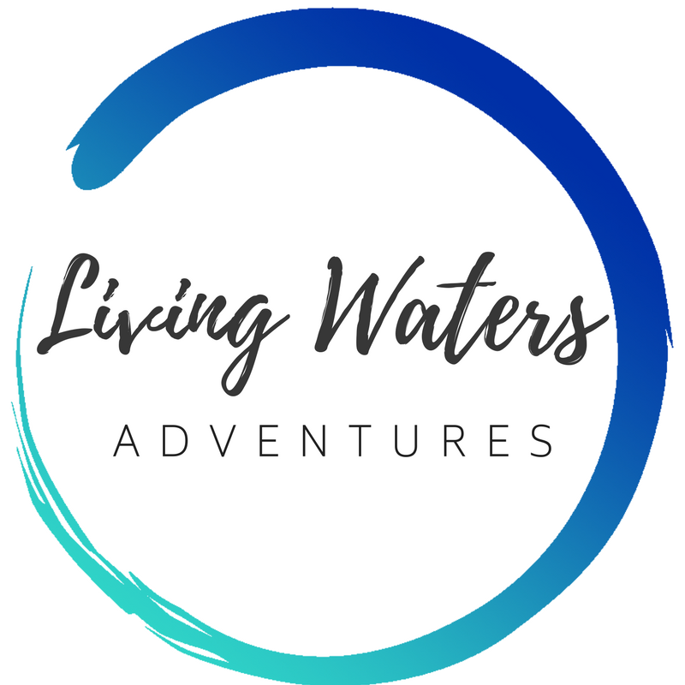

Final Application Form
Adult’s Version
(over 18 years of age by end of outreach)

Name:_________________________________________

Instructions:
- Except where indicated, each family member is to complete this entire form.
- Follow the check list below and mail this application form to:
Living Waters Spanish, PO Box 744, Canby, OR 97013
Apply:
- Pray about whether God would have you go on this outreach.
- Complete the Preliminary Application Form, online.
- Pay the trip deposit online (or mail a check to Living Waters Spanish, PO Box 744, Canby, OR 97013).

Complete the Final Application Form, including the following:
- Medical Emergency Contact Information
- Notarized: Authorization and Consent for Medical Treatment form.
  - Plus copy of both sides of your medical insurance card
- Activity Release of Liability form.
- Background Check form (18 and over only: Protect Ministry; Accufax; Instant Checkmate.)
- Reference Questionnaire – to be filled out by a Pastor or Christian Leader (not required if you’ve been on a previous Living Waters Spanish mission trip, or if the Rieggs vouch for you.)
--------------------------------------
If you are applying for an international trip outside of the US, also complete the following:
- If you do not have a passport that is valid for 6 months past your trip return date, order one at least 6 weeks before the departure date. Order at: US Passport, or if near Lake Oswego, Oregon, their Passport Office is helpful and efficient.
- Get any required vaccinations from your doctor long before departure. If you are not fully vaccinated, also sign the Participant Release of Liability Form for Vaccinations.
- Consent to Drive Internationally (25 years old and over only, and optional)
  - Plus copy of both sides of both your driver’s license and your driving insurance card
--------------------------------------
- Mail this completed application form to Living Waters Spanish, PO Box 744, Canby, OR 97013.
- Submit the balance of the outreach payment on time online, or mail it to Living Waters Spanish, PO Box 744, Canby, OR 97013.
Preparing to go:
- Book your flight to the meeting point and be sure you are arriving early enough and departing late enough to meet the parameters of your trip schedule. It is wise to buy flight insurance.
- Send personal letters to friends and family asking for prayer and financial support. Possible prayer points:
  - The Lord provides many participants for this outreach: “The harvest is plentiful, but the workers are few.”

  - Each participant gets a solid prayer team
  - Our hearts to be ready to serve
  - Blessings for on-site staff and students
  - Financial support
  - Health
  - Our practical preparation goes smoothly
  - Ability to communicate well
  - Evangelism, before, during and after the outreach

- Download and begin the Living Waters Spanish Journal before the outreach.
- Share your testimony and faith in Christ with people before, during and after the outreach.
  - If your Spanish is up to it: Translate your testimony into Spanish and practice saying it.
- Order the tracts and Bibles you want for the outreach.
MEDICAL EMERGENCY INFORMATION

FULL Legal Name (as shown on your passport): _____________________________________________________
Contact #1 (someone not going on this outreach)
Name: __________________________________________ Relationship to applicant: ______________________
Mailing Address: _____________________________________________________________________________
Street, Box #, or R.R. City State Zip/Postal Code
Phone numbers: (home) ___________________ (work) ___________________ (mobile) ___________________
Contact #2 (someone not going on this outreach)
Name: __________________________________________ Relationship to applicant: ______________________
Mailing Address: _____________________________________________________________________________
Street, Box #, or R.R. City State Zip/Postal Code
Phone numbers: (home) ___________________ (work) ___________________ (mobile) ___________________
Medical Insurance Carrier:__________________________________________________

Policy Number:_______________________ Group Number: _______________________

If you will be on an international trip, please provide the following:

Passport Number: ___________________________ Expiration Date: _______________ Birthplace: ________________
(Write “Pending” if you have applied for but not yet received your passport) Country

PHOTOCOPY OF MEDICAL INSURANCE CARD

FULL Legal Name: _____________________________________________________
Attach (below, or on a separate page) a photocopy of your medical insurance card, front and back:
PHOTOCOPY OF PASSPORT

FULL Legal Name (as shown on your passport): _____________________________________________________
Please place a photocopy of the main pages of your passport below (or on a separate page):
NOTARIZED - AUTHORIZATION AND CONSENT FOR MEDICAL TREATMENT

If the Applicant is 18 years of age or older, and is legally capable, he/she must sign the consent for medical treatment for himself/herself.

Medical Release for ADULT (18 years of age or older)
We (I) authorize Living Waters Spanish ("LWS"), of PO Box 744, CANBY, Oregon, 97013, or any adult of whom LWS asks assistance, permission to
authorize whatever medical treatment may be necessary for me, ________________________________________ , while on an outreach with LWS. If such treatment is recommended by a competent physician or surgeon and is performed by qualified medical personnel, I will not hold LWS, or anyone connected with LWS, responsible in case of adverse results or problems that arise from such treatment. It is understood that this release is valid only in an emergency situation where I am unable to consent to the medical treatment deemed appropriate for my care. I shall be liable and agree to pay all costs and expenses incurred in connection with such medical and dental services rendered to me. Should it be necessary for me to return home due to medical reasons or otherwise, the undersigned shall assume all transportation costs.

___________________________________________
Signature of Applicant/Participant Date
STATE OF COUNTY OF

The foregoing was signed before me this day of , 20

Notary Public SEAL

BACKGROUND CHECK
(Applies only to 18+ year olds while on the trip)
Step 1

Everyone who is 18 years or older before the end of your trip, needs to get a background check from one of the following sites:
- Protect Ministry
- Accufax
- Instant Checkmate

Step 2

Once you have obtained your background check report, include it with this Final Application Form.

Step 3

Read and complete the following:

I understand that according to the Federal Fair Credit Act, I am entitled to know whether volunteer service was denied based upon the information obtained and to receive, upon written request, a disclosure of the background report. After reading this document, I fully understand its content and authorize the background verification. I also certify that the answers provided below are accurate to the best of my knowledge and belief. I am aware that failure to complete this application, intentional omissions or misstatements may result in refusal of volunteer eligibility. Should my application be accepted, I agree to be bound by the policies of LWS and to refrain from unscriptural conduct in the performance of my services on behalf of LWS.

Have you, at any time, ever: Been arrested for any reason? ___Yes ___No
Been convicted of, or pleaded no contest to, any crime? ___Yes ___No
Engaged in, or been accused of, any child molestation, exploitation, or abuse? ___Yes ___No
Are you aware of having any tendencies that could pose any threat to children, youth, or others? ___Yes ___No
Is there any reason why you should not work with children, youth, or others? ___Yes ___No
If the answer to any of these questions is “Yes,” please explain in detail below:

___________________________________________________________________________________________

___________________________________________________________________________________________

___________________________________________________________________________________________

Print Name: ___________________________________ ____________________________ ________________
Signature Date
PHOTOCOPY OF BACKGROUND CHECK FROM ONE OF ABOVE, LISTED SOURCES

Please attach a copy of your background check report, below, or on separate pages.

CONSENT TO DRIVE INTERNATIONALLY
(Only for drivers 25+ years old who are applying for a trip outside of the US,
and who are willing to drive, if needed)

Would you be willing to drive an automobile while on this outreach, if needed?: _____Yes _____No

- If you answered ‘Yes,’ above, please attach the following:
  - A copy of your Driver’s License, front and back,
  - A copy of your driver’s insurance policy.

When traveling overseas, other than to Mexico or Canada, apply for an International Driving Permit, even if you are not planning to drive. (International Driving Permits are NOT required in Mexico or Canada.) Should you need to communicate with foreign authorities, this recognizable form of identification can help you get on your way more quickly. Valid in over 150 countries, the permit contains your name, photo and driver information translated into ten languages. Apply for one at the AAA office nearest you: Either mail the following items or bring them with you when you visit the AAA office:
- A completed International Driving Permit application (https://www.tripsavvy.com/international-drivers-permit-468481),
- A photocopy of both sides of your driver's license,
- $15,
- Two ORIGINAL passport-type photos (for acceptable digital photographs quality, see http://travel.state.gov/passport/get/first/first_827.html.)

PHOTOCOPY OF DRIVER’S LICENSE

A copy of your driver’s license is only needed for those who are willing to drive while on the trip.
FULL Legal Name (as shown on your driver’s license): _____________________________________________________
Please place a photocopy (below or on a separate page) of the FRONT and BACK of your driver’s license:

PHOTOCOPY OF AUTO INSURANCE

A copy of your auto insurance is only needed for those who are willing to drive while on the trip.
FULL Legal Name (as shown on your driver’s license): _____________________________________________________
Please place a photocopy of your auto insurance plan below (or on a separate page):

ACTIVITY RELEASE OF LIABILITY
READ CAREFULLY - THIS AFFECTS YOUR LEGAL RIGHTS

In exchange for participation in the activity of Mexico outreach (“Outreach”) organized by Robert Bradley Riegg, Marcy Shaffer Riegg, and Living Waters Spanish ("LWS"), of PO Box 744, CANBY, Oregon, 97013 and/or use of the property, facilities and services of LWS, I agree for myself and for the members of my family, to the following for the Outreach and all Outreach-related activities:

1. I agree to observe and follow all rules and directions given by LWS, or the employees, representatives, volunteers or agents of LWS, including, but not limited to, Marcy Riegg, and Robert Riegg.
2. I recognize that there are certain inherent risks associated with the Outreach and I assume full responsibility for personal injury to myself and my family members, and further release and discharge LWS for injury, loss or damage arising out of my or my family's use of or presence upon the facilities of LWS, or my family's use of the services of LWS, whether caused by the fault of myself, my family, LWS or other third parties.
3. I agree to indemnify and defend LWS against all claims, causes of action, damages, judgments, costs or expenses, including attorney fees and other litigation costs, which may in any way arise from my or my family's use of or presence upon the facilities of LWS or my or my family's use of the services of LWS.
4. In the event of emergency, I hereby authorize an adult leader of this activity, as my agent, to consent on my behalf to medical treatment. In this regard, I consent to allow said adult to authorize medical, dental, or surgical diagnosis, X-ray examination, and treatment including surgery and hospital care for me if needed and if advised and supervised by a license physician, surgeon, or dentist. In the event of my death, I understand that the country I am in may not allow my body to be shipped home.
5. I agree to pay for all damages to the facilities of LWS caused by my or my family's negligent, reckless, or willful actions.
6. Any legal or equitable claim that may arise from participation in the above shall be resolved under Oregon law.
I HAVE READ THIS DOCUMENT AND UNDERSTAND IT. I FURTHER UNDERSTAND THAT BY SIGNING THIS RELEASE, I VOLUNTARILY SURRENDER CERTAIN LEGAL RIGHTS
Dated: _________________________, 20____
__________________________________________________________________
Printed Full Name of Participant
___________________________________________________________________
Signature of Participant
Address: ___________________________________________________________________

VACCINATIONS LIABILITY RELEASE AND WAIVER

1. I, the undersigned participant, acknowledge that I have been urged by Living Waters Spanish to obtain a vaccination against 1.)Meningococcal disease, 2.) Measles, Mumps and Rubella (MMR), 3.) Tetanus, Diphtheria and Pertussis (TDaP) and 4.) COVID-19 (hereinafter collectively “Vaccination”), as recommended by the Centers for Disease Control.

2. The benefits of receiving the Vaccination have been explained to me and I fully understand and appreciate the dangers, hazards, and risks that may arise from not being vaccinated. These dangers, hazards, and risks can result in impairment to my body, general health, well-being, and could include serious or even fatal results.

3. Knowing the dangers, hazards, and risks of not receiving the Vaccination, on behalf of myself, my family, spouse, heirs, and personal representative(s) (the “Releasors”), I agree to assume all the risks and responsibilities surrounding my failure to be vaccinated. On behalf of myself and the Releasors I hereby covenant not to sue Living Waters Spanish, or its employees or representatives (“Releasees”), and I hereby release, waive, and forever discharge the Releasees from and against any and all liability for any harm, injury, damage, claims, demands, actions, causes of action, costs, and expenses of any nature that I may have or that may hereafter accrue to me or a Releasor, arising out of, or related to, my failure to receive the Vaccination. It is my expressed intent that this Liability Release and Waiver shall bind me, the members of my family and spouse, if I am alive, and my estate, family, heirs, administrators, personal representatives, or assigns, if I am deceased, and shall be deemed as a legally binding release, waiver, discharge and covenant not to sue the Releasees.

THIS IS A LEGAL AGREEMENT AND INCLUDES A RELEASE OF LEGAL RIGHTS. READ AND BE CERTAIN YOU UNDERSTAND IT BEFORE SIGNING.

Dated: _________________________, 20____
__________________________________________________________________
Printed Full Name of Participant
___________________________________________________________________
Signature of Participant
Address: ___________________________________________________________________

Reference Form
Only 1 form required per family that has never had at least 1 family member previously attend a Living Waters Spanish mission trip or who is not well known by the Rieggs.

Instructions: Please give this questionnaire to a Pastor or Christian Leader who knows you well, to be completed by him or her. Use additional paper when necessary, and indicate which question number is being answered.

____________________________________ has applied to take part in an outreach with Living Waters Spanish.
Name of Mission Trip Applicant

This outreach will take them to an international location to minister to people’s needs and share the gospel. The participant may face stressful situations both because of cross-cultural transition and because of team dynamics. Your honest evaluation will help us accurately assess this applicant. Please complete and mail this referral to Living Waters Spanish, PO Box 744, Canby, OR 97013. Your reply will be held in confidence.

1. Your (pastor’s) name and title: ______________________________Phone number with area code:________________
2. How long have you know the applicant, and in what type of relationship?_____________________________________
3. How have you seen the applicant grow spiritually? _______________________________________________________
4. Have you observed the applicant’s ability to relate with people, including leaders? Try to comment on his/her relational style, congeniality, cooperation, and potential for conflict.

_________________________________________________________________________________________________
5. What strengths or gifts will this applicant bring to the team? ______________________________________________
6. Please rate the applicant from 1 to 5 in the following areas, where “1” represents “does not describe the applicant” and “5” represents “describes the applicant very well.”

_____ Resourceful _____ Adapts easily to changing circumstances _____ Self-motivated _____ Careful
_____ Responsible _____ Attentive to detail _____ Expresses his/her thoughts well _____ Easily makes friends
_____ Expresses his/her feelings well _____ Knows Scripture
Signature __________________________________________ Date ____________________
Thank you for your time and assistance! If you have any questions, please note them below. Please mail this form to:
Living Waters Spanish
PO Box 744
Canby OR 97013

